

Avaya Professional Services

**Housing Development Board (HDB) Contact Center Upgrade Project**

**Functional Design Specification**

**for Properties & Land Group (PLG)**

**Project Code:** I18SG1042

**Table of Contents**

1 Glossary of Terms 4

2 Introduction 4

3 Proposed System 5

3.1.1 Control Manager 5

3.1.2 Avaya Breeze 5

3.1.3 Workspaces for Elite 5

3.1.4 Presence Services 6

3.1.5 Multimedia Messaging 7

3.1.6 Work Force Optimization Quality Monitoring with Speech Analytics 7

4 Workspaces Client 8

4.1 Workspace Login 8

4.2 Agent Workspaces 8

4.2.1 Agent Interaction Cards 9

4.2.2 Agent Codes 9

4.2.3 Agent After Contact Work 10

4.2.4 Agent Workspaces Voice Contacts 10

4.3 Supervisor Workspaces 11

4.3.1 Supervisor Team Widget 11

4.3.2 Supervisor Agent Broadcast Messages 12

4.4 Instant Message (IM) Widget 12

4.4.1 Conversation View 13

4.4.2 Contact List Tab 14

4.5 Screen Pops for Inbound 16

4.5.1 PLG Inbound Screen Pop 16

5 Design Definition Acceptance 17

5.1 Signature Block 17

**Working Changes Summary**

|  |  |  |  |
| --- | --- | --- | --- |
| **Version** | **Date** | **Author** | **Summary** |
| 0.1 | 11-19-2018 | Ming Gao | Initial Draft |
| 0.2 | 11-19-2018 | Ming Gao | Updated figure 1 |
| 0.3 | 11-21-2018 | Ming Gao | Update 4.4 Instant Message Widget, to put on more details on the presence service |

# Glossary of Terms

The table below defines the Avaya terminology that may be used throughout this document.

|  |  |
| --- | --- |
| Term | Description |
| ANI | *Automatic Number Identification* – Telephony feature that identifies the number of the originating telephone. |
| Collected Digits | Digits that are prompted for and collected by the ACD. |
| DNIS | *Dialled Number Information System* – The destination number |
| CS | *Context Store* |
| ED | *Engagement Designer* |
| WA | *Work Assignment* |
| RSS | *Resource Selection Strategy* |
| WSS | *Work Selection Strategy* |
| EP | *Experience Portal* |
| CM | *Communication Manager PBX* |
| VXML | *Voice eXtensible Markup Language* |
| CCXML | *Call Control eXtensible Markup Language* |
| ACM | *Avaya Control Manager* |

# Introduction

This document outlines the functional design specification for the following systems:

* Oceana/Workspaces for Elite
* Avaya Control Manager
* WFO – QM & Speech Analytics

# Proposed System

This section provides an overview of the project and introduces the technology that is being proposed to meet the projects goals. The Workspaces for Elite solution is then presented in more detail.

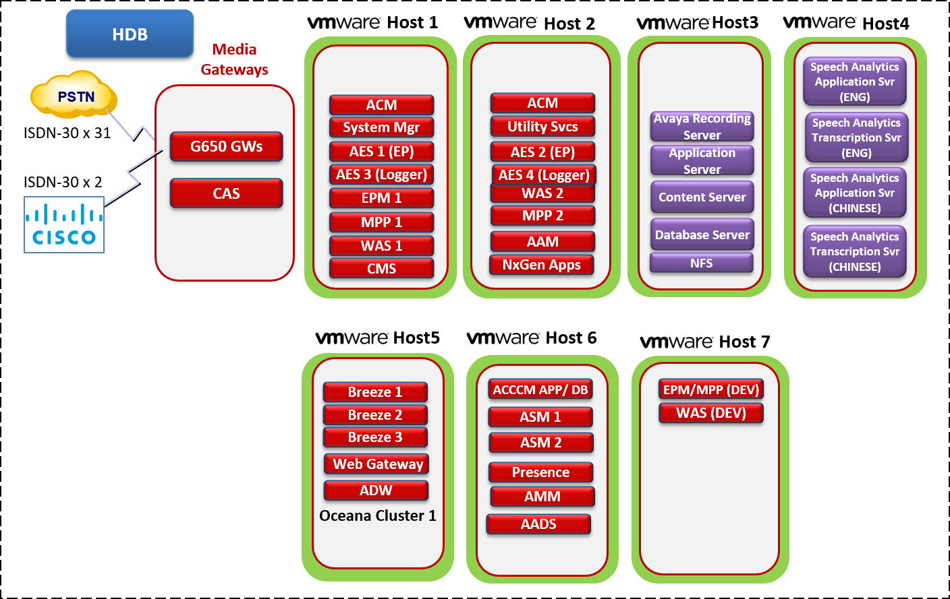

Figure 1 - Systems Server Layout

The Housing Development Board (HDB) solution consists of the following components:

### Control Manager

Avaya Control Manager will be used for management of users within the Avaya Aura & Workspaces for Elite environments. Control Manager is a centralized web-based management environment using Role Based Access. With Control Manager, users can be assigned with different roles and responsibilities based on their login credentials, from high-level to granular level capabilities.

### Avaya Breeze

Breeze provides a pre-built framework for Avaya to easily deploy applications known as snap-ins without to start the application from scratch. The Breeze platform uses an in-built data grid, message bus and web-based business process graphical design tool. Breeze supports a set of ReST Web service APIs for call control and voice messaging operations. Breeze applications are written in Java or can be designed using a graphical interface which is the Engagement Designer.

### Workspaces for Elite

Avaya Workspaces for Elite is a browser-based application with which you can handle customer interactions. Interaction is a communication between you and the customer. Avaya Workspaces for Elite supports the voice channel only. You can also make outbound voice calls. The intuitive user interface provides features for toggling between multiple interactions.

Avaya Workspaces for Elite enables seamless collaboration with customers, partners, and other users within and outside the organization. It also provides relevant information to agents securely and reliably.

Avaya Workspaces for Elite displays every interaction as an interaction card. Using interaction cards, you can:

* Receive the interaction. You can accept interactions with a single click.
* Hold or resume the interaction. You can put an active voice interaction on hold when another interaction with a higher priority must be attended to.
* Consult another agent. You can seek advice about an interaction.
* Transfer the interaction to another agent. You can send the interaction to another agent interaction area.
* Add another agent to the interaction. You can create a conference with another agent when the other agent can contribute to resolving the customer interaction.

To enhance accessibility, Avaya Workspaces for Elite provides:

* Access to most content and controls by using the keyboard.
* Alternative text and labels to assist users with screen readers.

Avaya Workspaces for Elite supports screen magnifier tool, such as Magnifier, to zoom in and out of Avaya Workspaces for Elite screens.

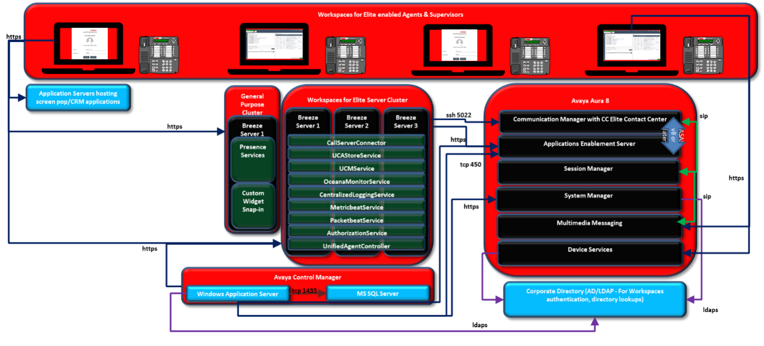

Figure 2 - Workspaces for Elite Applications Layout

### Presence Services

Avaya Aura® Presence Services Snap-in provides a scalable, high performance presence aggregation service. Avaya Aura Presence Services collects and disseminates rich presence from Avaya and third-party sources across a diverse set of business environments. The presence information allows users to locate colleagues and experts to address customer inquiries, handle service issues, and solve critical problems in real time. It helps to expand contact center capabilities by leveraging resources and expertise across the entire enterprise to serve customers better.

### Multimedia Messaging

Avaya Multimedia Messaging provides advanced multiparty instant messaging (IM) and rich media exchange capabilities to Avaya Unified Communications (UC) applications.

### Work Force Optimization Quality Monitoring with Speech Analytics

The WFO suite allows for the Avaya Contact Recorder to be connected to WFO Enterprise Manager to provide audio and screen recording services for Quality Monitoring, Desktop Processing and Analytics, Speech and Scorecards. These are the latest evolution of products provided with the Workforce Optimization suite.

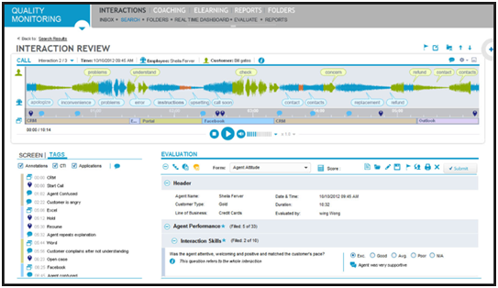

Figure 4 - Quality Monitoring Sample Interface

**Application Interface**

HDB will be using the Quality Monitoring component of WFO which is a web-based solution that enables supervisors to record and replay voice and screen from customer interactions as well as many other features which allow for the monitoring of agents more efficiently.

The Enterprise Manager is the web-based application that enables most of the configuration for the WFO suite and the EMA is a component on the Avaya Contact Recorder responsible for communication between Enterprise Manager and the recorder.

Quality Monitoring is a software application customarily used for contact center quality monitoring and performance optimization. With QM, the voice interaction along with agent screen activity can be captured for later review and evaluation. Voice and data (screen) can be randomly captured or recorded based on user-defined business rules. The QM application also includes a customer-defined evaluation form development module and agent performance reporting based on completed evaluations.

The QM application uses the Contact Recording Package as the underlying recorder for both voice and screen in a Quality Monitoring implementation and will downloads a copy of voice and screen from the ACR for playback but deletes the entry from the cache after the supervisor is finished, this way there is no call storage required on the WFO server.

# Workspaces Client

This section outlines the Workspaces client and the out of the box functionality available for both agents and supervisors. The complete user guide and reference for the Workspaces for Elite Client is available at: <https://downloads.avaya.com/css/P8/documents/101051556>

## Workspace Login

Agents login into Workspaces for Elite using LDAP credentials. Additionally, for voice, agents must use an Avaya desk phone, Avaya one-X® Agent, or Avaya Agent for Desktop. Telecommuter mode is currently not supported.

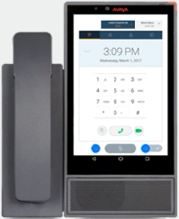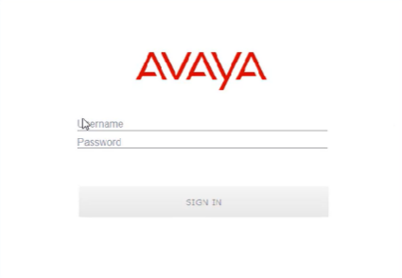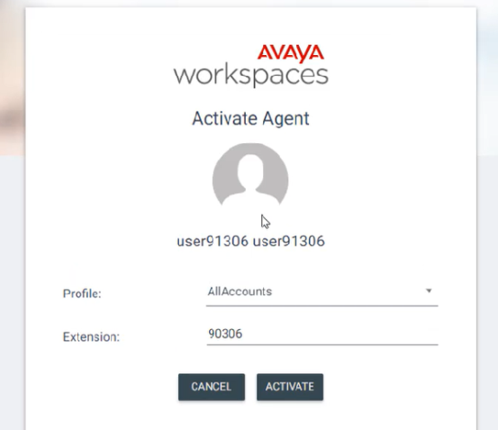

## Agent Workspaces

This section of the document outlines the Agents Workspaces client out of the box functionality.

### Agent Interaction Cards

Each incoming contact will have an individual contact card. Cards are color coded to show the cards current status.

* Green –Active Contact Card
* Gray – Inactive Contact Card
* Orange – Incoming Contact Card
* Blue – Contact Card on hold

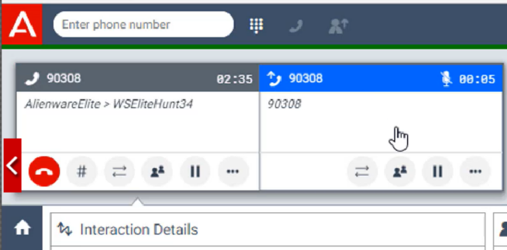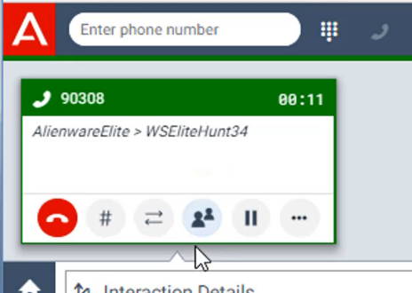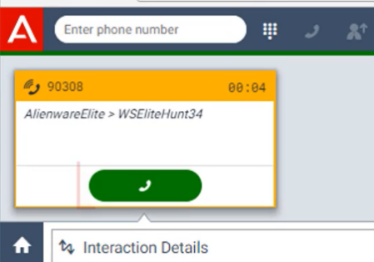

During After Contact Work, Avaya Workspaces retains the interaction card after the interaction has ended until the Agent dismisses it.

Avaya Workspaces also retains the interaction card after:

* Transferring an interaction.
* Completing a consulted transfer. Avaya Workspaces retains the interaction card of both the agents.
* The Agent ends the routed and direct interactions.

While an interaction card is in After Contact Work, you cannot make any change to the card. Avaya Workspaces retains the interaction card on the client side only.

### Agent Codes

Agents will have the ability to enter AUX codes from Workspaces. AUX codes are currently defined for the Elite solution will be configured in the Control Manager.

|  |  |
| --- | --- |
| **AUX Code** | **AUX Code Name** |
| 0 | System |
| 1 | Lunch Break |
| 2 | Rest Break |
| 3 | Meeting |
| 4 | TEST |
| 5 | Call OUT |

The code selected will be visible in real-time reports and the supervisor team view. The codes are also historically reportable.

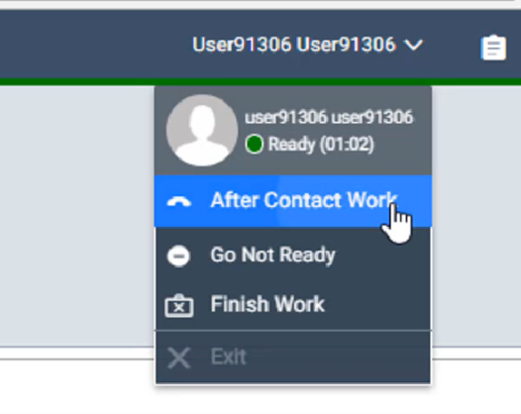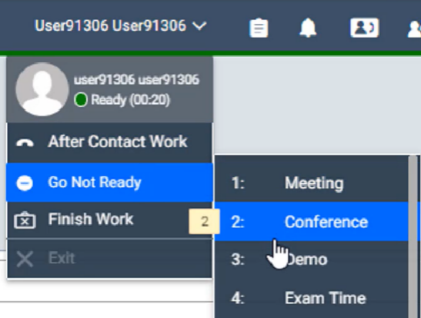

### Agent After Contact Work

The limited time will give the agents a set time of After Contact Work for each and every contact. The customer can end After Contact Work earlier or let the timer run out. When the timer runs out, the agent is immediately available for a new contact.

The Agent Extend timer allows an agent to extend the After Contact Work indefinitely. There is no forced limit so the agent could leave themselves in After Contact Work as long as required.

After Contact Work time is reportable down to the individual interaction it is associated with.

### Agent Workspaces Voice Contacts

This section shows a Voice contact in greater detail.

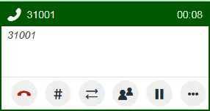

Options Available (in order):

* Disconnect
* DTMF (Dial Pad)
* Transfer
* Conference
* Hold
* More Options (Work Codes, Interaction Details)

For Voice Conferences the agent can utilize the Team list to select a person or can manually enter the phone number. For Transfers the agent can selected from a pre-defined list of internal transfer queues, the Team List or manually enter the phone number.

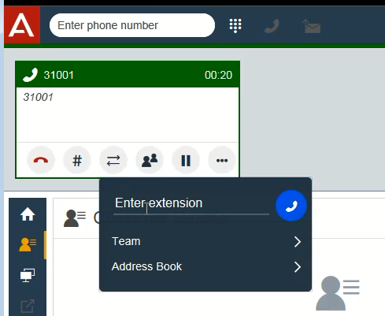

## Supervisor Workspaces

Supervisors have additional functionality within workspaces that allow them to monitor and interact with the agents and the queue. This section will outline the additional supervisor functionality.

### Supervisor Team Widget

Supervisor has Team widget to see the status of all his/her agents. Agent state can be controlled by the supervisor e.g. Logout an agent who has gone home. This view has the ability to search or apply filters to the list of agents. Filters can be applied by channel or agent state. This can help a supervisor quickly see the current status of all agents assigned to them.

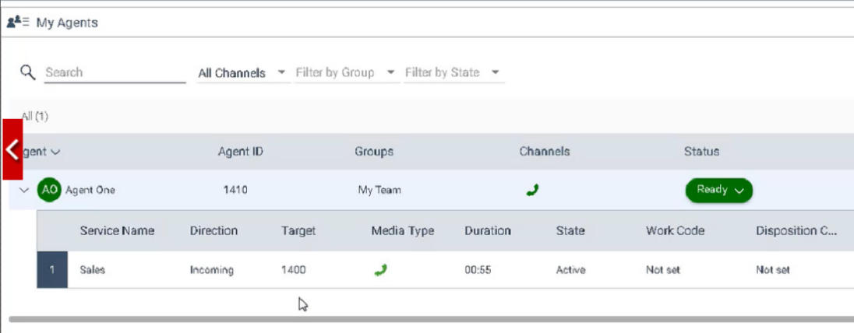

### Supervisor Agent Broadcast Messages

Supervisors can use the Team Widget to send Broadcast Messages to all currently logged in agents. Any agent that is currently logged in will receive the message as a small blue pop up in the workspaces client. The message will then be written to the agents Notification list. If the Agent is not at their desk they can see the notification in the list.

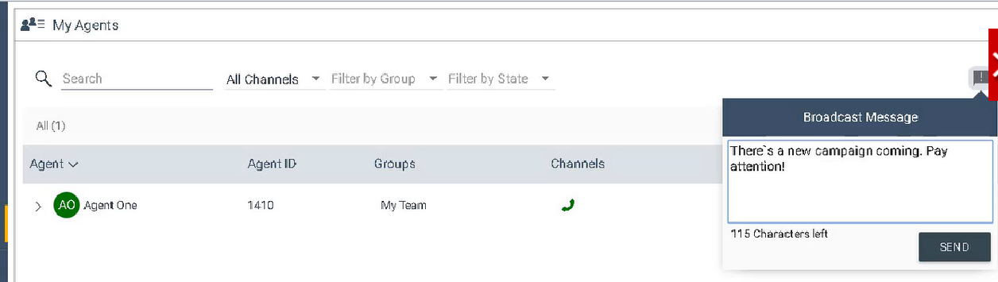

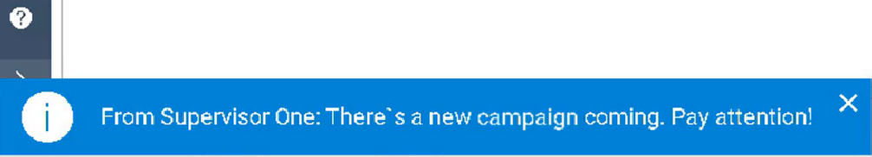

## Instant Message (IM) Widget

Instant message widget enables supervisors and agents to chat or share documents with each other easily.

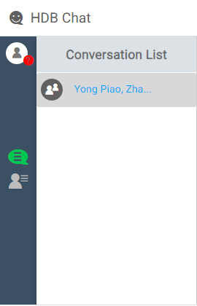

There are 2 views provided by instant message widget:

* Conversation View (click on  button, to go to the view)
* Contact List View (click on  button, to go the view)

Key features of instant message widget:

* Private chat (1 to 1 chat)
* Group chat
  + Any agent or supervisor can create their own chat groups by adding multiple contacts.
  + A chat group is only visible to the ones who have been already added to the chat group.
* Message format is in rich text (color, bold, italics, underline)
* Sending Documents
* Hyperlink in the message
* Multilingual text input supported:
* Pop up alerts for new messages
* For private chat, one party in the chat can see if the other party is typing

e.g. when agent A is chatting with agent B, and during the time when agent A is typing, agent B could see form the chat window that “agent A is typing…”. And vice versa.

* Send text message to an offline contact
* By default, messages are all encrypted
* View others’ presence status. The presence status is agent’s phone status, e.g., on call, available, away. Presence status can’t be set manually.
* When a user logins Oceana workspace, IM won’t login. To use IM, user needs to login IM from IM widget separately.

**Note:** User only needs to enter the password again to login IM, as the username will be automatically displayed on IM login window. IM login needs same user used by Oceana workspace.

### Conversation View

Conversation View, is used for private chat and group chat conversations.

Follow functions are provided by this view:

* Display the list of active conversations
* Initiate a new chat and leave a chat.

**Note:** If a participant has completed private chat or group chat and wants to close the chat window, he or she needs to press “Leave conversation” button, so that the conversation is dismissed. If it is a group chat, after clicking “Leave conversation”, he or she will quit from the chat group, and stop receiving messages in the chat group.

* Add more people to chat
* Edit chat group name
* Send text messages
* Send documents (word, excel, pdf, ppt, etc.)

Please note the below restricts for Conversation View:

* Chat shown in the conversation history window is not editable, nor can be searched.
* Instant message widget is only available between agents or supervisors who already login Oceana Workspace or temporarily offline. It can’t be used to chat with someone who is not using Avaya Oceana.
* During group chat, no one can block or remove others from the chat.
* Any other rich text and text format which are not defined in the design document are not supported
* Copy/paste text is supported, but after text is pasted into chat input window, it will be in plain text, and the previous format won’t be retained.
* Can’t copy/paste tables.
* Emoji not supported

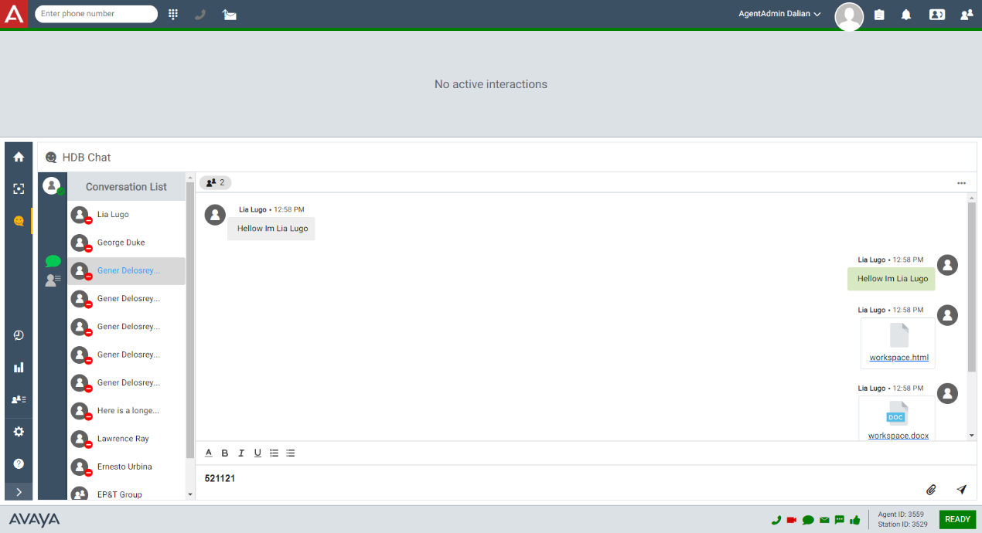

### Contact List Tab

Contact List tab is used for user to manage their contact list. It provides the following functions:

* Search the contact by first name, last name or email address
* Display personal contact list
* Search contact result and contact list will also present contact presence status
* Add the contact in the personal contact
* Remove the contact from the person contact list
* Initiate conversation from the search result or contact list

Please note the below restricts for Contact List View:

* The person who already in the contact list cannot be added into the contact list again and add button would be invalid.
* The contact list or search result will be sorted by contacts’ “Last name”
* The contact list or search result only present contact last name and first name using the format “Last Name, First Name”
* When user clicks the “initiate conversation” button, if the conversation is already active in conversation list, then the existing conversation will be presented rather than create duplicated new conversation

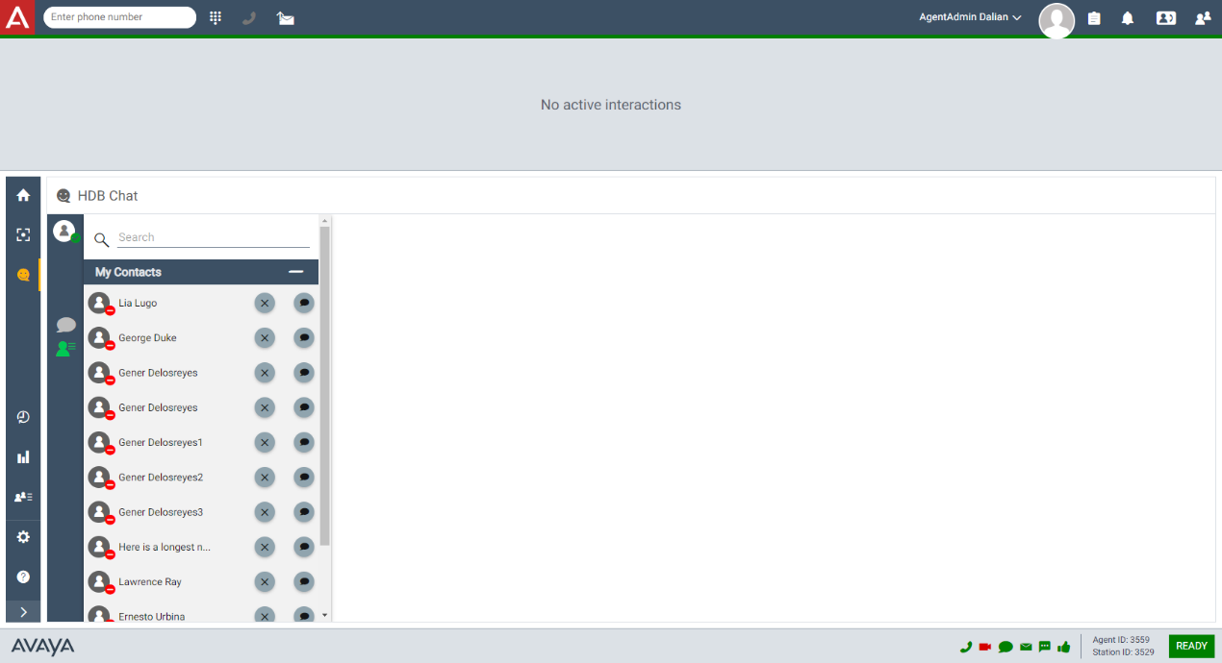

## Screen Pops for Inbound

Oceana Workspace Client provides screen pops for agents who handle inbound calls.

### PLG Inbound Screen Pop

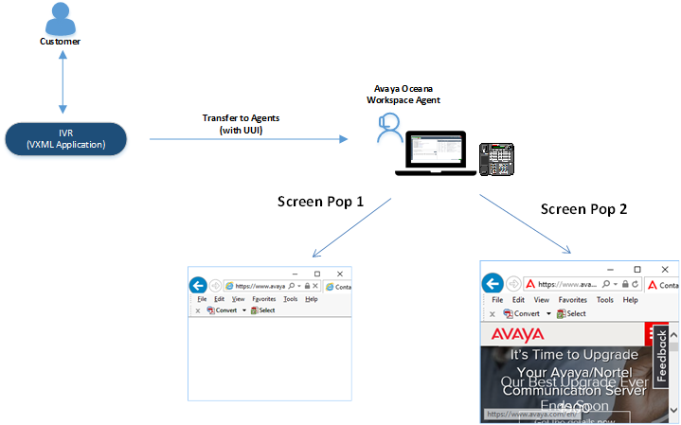

IVR collects customer’s HDB reference number and call ID. The collected info will be stored into UUI, when customer requests call transfer to agent, IVR will transfer call to inbound agents with UUI.

Screen pops are used to open browsers when an incoming call is answered by an agent.

There are 2 screen pops:

* **RMS Page**
* **Call History Page**
* **RMS Page**
  + The screen pop will be opened by a customized widget in Oceana Workspace.
  + **RMS** is opened via a dynamic URL with 1 parameters, HDB reference number.

Sample URL to open CRM page:

*http://<Static URL>?<HDB Reference Number>*

* + It is opened automatically when the call is answered by agent.
  + Agent needs to manually close the window when call finishes.
* **Call History Page**
  + The screen pop will be opened by a customized widget in Oceana Workspace.
  + **Call History** is opened via a dynamic URL with 2 parameters, HDB reference number and Call ID

Sample URL to open CRM page:

*http://<Static URL>?<HDB Reference Number> & <Call ID>*

* + It is opened automatically when the call is answered by agent.
  + Agent needs to manually close the window when call finishes.
  + Matrix for whether HDB reference number or call ID will be used by CRM side:

|  |  |  |  |
| --- | --- | --- | --- |
| **Scenario 1** | **Scenario 2** | **Scenario 3** | **Scenario 4** |
| HDB Ref Number  +  Blank | HDB Ref Number  +  Call ID | Blank  +  Call ID | Blank  +  Blank |
| CRM uses HDB ref | CRM uses HDB ref | CRM uses Call ID | Blank page will be popup |

# Design Definition Acceptance

## Signature Block

The signature below represents Housing Development Board (HDB)’s acceptance of this Solution Requirements Definition document. Any changes to the requirements of the Workspaces for Elite system not defined in this document will be moved to an additional phase with a Change Request Form (CRF). Avaya must receive this signed Solution Requirements Definition before any implementation work can be performed. Please email to: [skawakami@avaya.com](mailto:skawakami@avaya.com)

|  |  |
| --- | --- |
| **Avaya Inc.** | **Housing Development Board (HDB)** |
|  |  |
| Signature | Signature |
| Project Manager - Avaya Inc. | Project Manager – Housing Development Board (HDB) |
| Date: | Date: |